Project Design Phase-II
Data Flow Diagram & User Stories
Date | 14 July 2026
Team ID | Geeta Rani
Project Name | ShopEZ
Maximum Marks | 4 Marks

Data Flow Diagrams:
A Data Flow Diagram (DFD) is a traditional visual representation of the information flows within a system. A neat and clear DFD can depict the right amount of the system requirement graphically. It shows how data enters and leaves the system, what changes the information, and where data is stored.
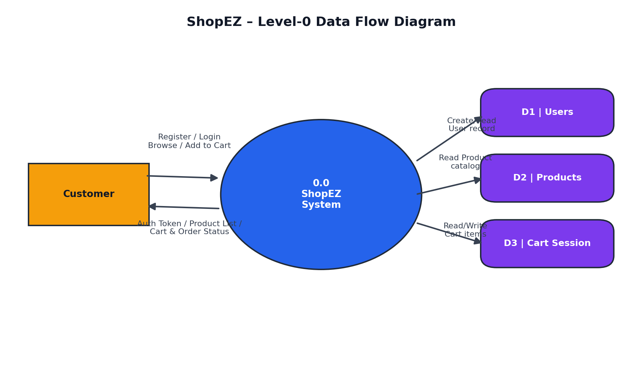

User Stories
Use the below template to list all the user stories for the product.
User  Type | Functional  Requirement  (Epic) | User  Story  Number | User Story /  Task | Acceptance  criteria | Priority | Release
Customer | Registration | USN-1 | As a customer, I can register using email and password. | Account created successfully | High | Sprint-1
Customer | Login | USN-2 | As a customer, I can log in securely. | JWT token issued and profile accessible | High | Sprint-1
Customer | Product Catalog | USN-3 | As a customer, I can view all available products. | Product grid displayed with price & rating | High | Sprint-1
Customer | Cart Management | USN-4 | As a customer, I can add a product to my cart. | Item appears in cart with quantity 1 | High | Sprint-2
Customer | Cart Management | USN-5 | As a customer, I can update item quantity in my cart. | Quantity and subtotal update instantly | High | Sprint-2
Customer | Cart Management | USN-6 | As a customer, I can remove an item from my cart. | Item removed and subtotal recalculated | High | Sprint-2
Customer | Currency Switcher | USN-7 | As a customer, I can switch the displayed currency. | Prices update to selected currency | Medium | Sprint-3
Customer | Profile | USN-8 | As a customer, I can view my profile details. | Name and email displayed after login | Medium | Sprint-3
Customer | Checkout | USN-9 | As a customer, I can view my cart subtotal before checkout. | Subtotal reflects all cart items correctly | Medium | Sprint-4
Customer | Session Persistence | USN-10 | As a customer, my session and cart persist on reload. | Cart and login state retained after refresh | Medium | Sprint-4

